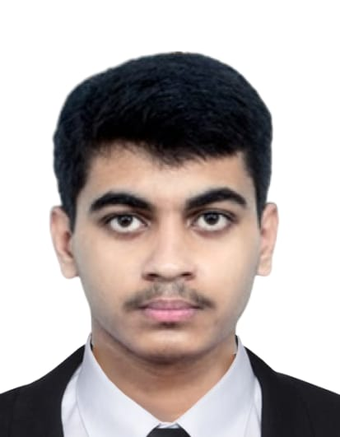
Divanshu

Cell: +(91) 8478044471
Email: divanshu1920@gmail.com
ABOUT ME
Career Objective
I want to persue my career in the field of Web development, Software engineering.

Personal Details
Father’s name – Sandeep Kumar
Date of Birth – 09/12/2003
Gender –Male
Languages known –English,Hindi,Bengali

Address – 181/2B Raipur road Kolkata-700047

Professional Experience
Have worked with BookMyShow and few other entertainment companies in managing events.

- Projects

- Computer Proficiency
- Python
- Java
- HTML
- CSS
- DBMS
- DSA

- Interests and Hobbies
- Have a keen interest in Finance
- Photograhy
- Coin Collection

- Activities and Achievements
- Active member of IT Club of Amity
- Won a medal in swimming for my department.

ABOUT ME

Academic Qualifications
Qualification | Name of School / College | Board / University | Year of Passing | Marks (in %) / CGPA
Graduation  (write name of degree/diploma) | Amity School of Engineering and Technology | Amity University | 2025 | 6.37
12th | UPASANA ACADEMY | CBSE | 2021 | 88.9%
10th | M.P.BIRLA FOUNDATION H.S.S | ICSE | 2019 | 71%

...........
Any other information (As applicable)
I, DIVANSHU student of Amity University Kolkata, hereby solemnly affirm and declare that what is stated is true to the best of my knowledge.
Date _____________________________
Place _____________________________
Signature _____________________________

